* **COVID-19 Updates and Communication**

**IMPORTANT UPDATES FOR SPRING SEMESTER**

**Dec. 28, 2021**

Due to the continuing health and safety risk posed by the COVID pandemic and the new omicron variant, Miles College has revised its plans for the beginning of the spring semester. These decisions are intended to support the safety of our community while continuing to offer the meaningful learning and living experiences that contribute to our students’ success.

This communication provides information on:

* + Spring semester starting on schedule and in-person
  + COVID testing before the semester starts
  + Masking requirements and recommendations
  + COVID testing during the spring semester
  + College events and activities
  + Vaccination reminder and booster recommendation

**Spring semester starting on schedule and in person**  
The College’s COVID Response Team continues to monitor data on COVID, public health guidance, and our internal data on transmission and vaccination. While COVID cases are generally rising, the College has a high vaccination rate and the ability to test and monitor cases. Therefore, we will start the spring semester as planned, with in-person instruction.  Additional precautions will be put in place as described below.

**Masking requirements and recommendations**  
Masking is still **required** **for everyone in all College buildings**. This requirement must be followed regardless of vaccination status by all students, faculty, staff, and visitors.

Masking is critical to reducing the likelihood of transmission of COVID infections within classrooms, while studying with others, and during College activities.

Masking is also **required in all residence hall shared spaces**such as lounges, hallways, and restrooms.

With the increased transmissibility of the omicron variant, **the College now recommends using level 3 surgical masks, KN95 masks, or double masking of cloth and disposable masks together.**  Cloth masks alone, bandanas, gators, or masks with valves are discouraged from use on our campuses.

**COVID testing before the start of the semester**  
As a precaution and to reduce transmission within the College, we have scheduled COVID testing before classes start. The following groups are **required** to be tested:

* + All students living in College -provided housing, regardless of vaccination status; and
  + All students and employees who are not vaccinated (i.e., individuals with a medical or religious exemption from COVID vaccination).

You can choose to be tested at the College (details below), or you can obtain a test in the community (with testing no earlier than Jan. 2) and email a verified document with the test result to healthctr@miles.edu before move-in and the start of in-person classes or activities.

For all residential students, regardless of vaccination status, testing must be completed before returning to the residence halls. Any residential student experiencing symptoms on the day they plan to move in should not return to the halls but should contact [Healthctr@miles.edu](mailto:COVIDResponse@capital.edu) for an assessment. If you test positive at move-in, you will be required to return home for your isolation period.

For unvaccinated employees and non-residential students, testing must be completed before classes start.

In addition, any students, faculty, and staff who would like to be tested before the start of classes can go for testing on campus.

**TESTING DETAILS**  
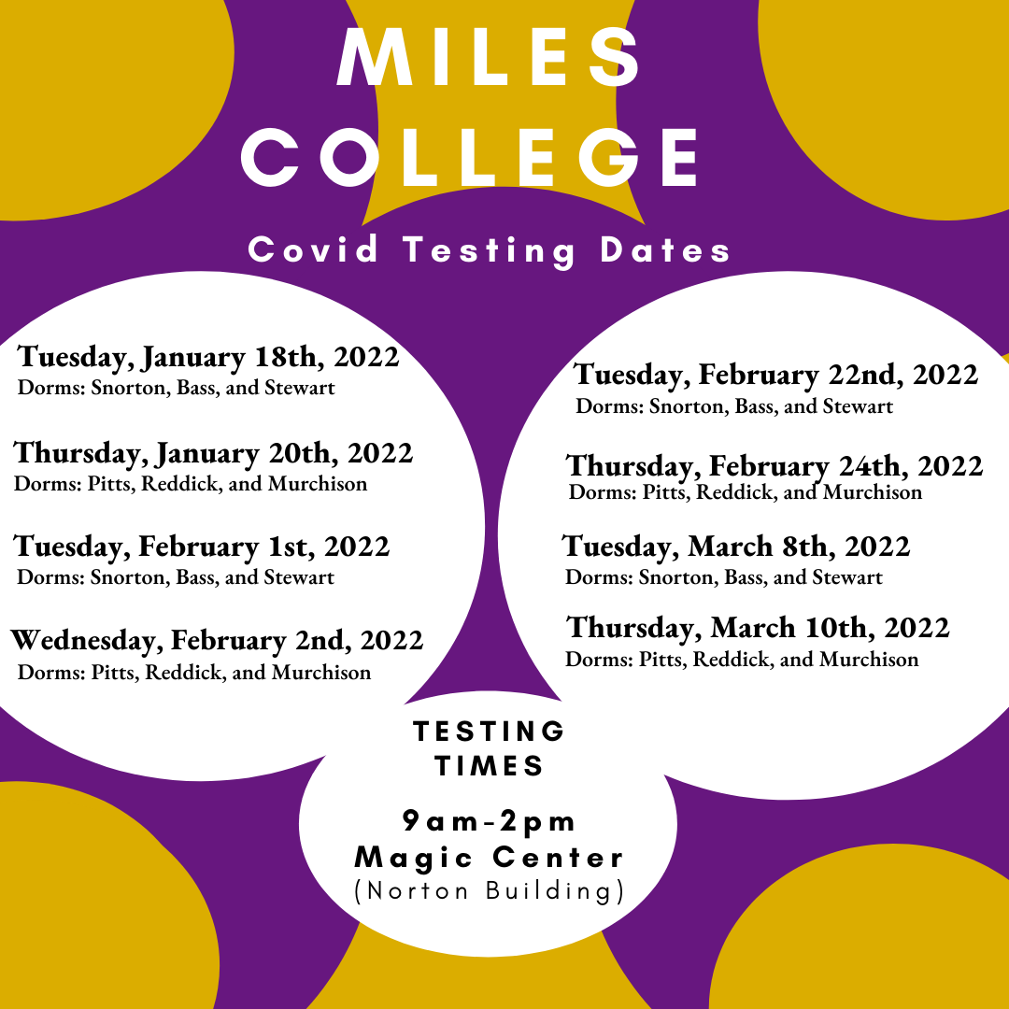

Individuals who are in their **90-day window after having COVID** are exempt from testing during those 90 days, but they **need to provide verified documentation** of their positive test result to healthctr@miles.edu before the start of the semester and in-person activities.

**Important:**If you have not tested through Miles College yet this academic year, please fill out the COVID testing form (PDF). Use the link below to upload your consent form and fill out the survey for the health department. Once we have this information in our system, you will not need to fill it out again this academic year. Please upload the COVID testing form (PDF) here:

Under medical records   
<https://www.miles.edu/covid-19-vaccination-cards-form>

**Testing during spring semester**  
To allow the COVID Response Team to monitor for COVID transmission at the College and respond to outbreaks quickly, the following testing will be done throughout the semester:

* + All unvaccinated students and staff who have a medical or religious exemption from COVID vaccination will be required to test every week.
  + 3% of vaccinated students will be randomly selected each week for surveillance testing.

Also, anyone with symptoms during the semester should email the [healthctr@miles.edu](mailto:healthctr@miles.edu) to receive an at-home test to take before continuing with classes or activities.

The College will provide testing at no cost to individuals. Compliance with the testing program is required, and non-compliance will result in disciplinary actions for students and employees.

**College events and activities**  
At this time, College events and activities can continue with masking required for everyone attending an on-campus event. It is recommended that events not include food to avoid mask removal.

**Vaccination reminder and booster recommendation**  
Vaccination is the most effective way of protecting yourself from hospitalization or death from a COVID illness. All students, faculty, and staff are **required** to be vaccinated for COVID or be approved for a medical or religious exemption.

If you still need to get one of your vaccination shots, you can use the state website at  <https://dph1.adph.state.al.us/covid-19/>/covid-19/ to find a location, the type of vaccine you prefer, and book an appointment.

If you need to submit your vaccination documentation, [upload your vaccine card showing all necessary COVID vaccine doses](https://www.miles.edu/covid-19-vaccination-cards-form).

The College **strongly recommends** that everyone eligible for a COVID booster get a booster shot as soon as possible. Individuals who have had their booster shots have better protection against the omicron variant of COVID.  Adults are eligible for a booster if it has been at least six months since you received both doses of the Pfizer or Moderna vaccines, or if it has been at least two months since you received the Johnson & Johnson vaccine. Booster shots can be scheduled using the state website at: <https://dph1.adph.state.al.us/covid-19/>/covid-19/

Contact the COVID Response Team at [Healthctr@miles.edu](mailto:COVIDResponse@capital.edu) if you have questions.

**Documents**

**COVID Vaccine Medical Exemption Form** (PDF)*

* + **COVID Vaccine Religious Exemption Form** (PDF)*

Once you have completed your exemption form, please visit the **COVID vaccine exemption upload form** to submit the document.

that getting vaccinated is the most effective way of protecting yourself from hospitalization and death.

Thank you for doing your part to keep the Capital community safe during the continuing pandemic. We will update our COVID policies and plans as appropriate to meet the changing climate.

Please reach out to our COVID Response Team at [Healthctr@miles.edu](mailto:COVIDResponse@capital.edu) if you have questions or concerns.

**Documents**

* + **COVID Vaccine Medical Exemption Form** (PDF)*
  + **COVID Vaccine Religious Exemption Form** (PDF)*

**Exemption Forms**  
COVID Vaccine Medical Exemption Form (PDF)*  
COVID Vaccine Religious Exemption Form (PDF)*  
*\*More information regarding how to submit your medical or religious exemption forms will be available soon.*

**How do I prove that I have received the COVID vaccine?**

Once you have been fully vaccinated, please **submit your vaccination status and upload an image of your vaccine verification card using this link:**

https://www.miles.edu/covid-19-vaccination-cards-form

If you do not have your vaccine card, you can submit written evidence of immunization from an authorized healthcare provider who provided the vaccine or a vaccination certificate from a state immunization registry.

Until further notice, everyone must continue to follow all College-required COVID health and safety protocols, including the College’s mask policy.

* + **Indoors**: Masks must be worn by all students, faculty, staff, and visitors, regardless of vaccination status, while in public indoor spaces on all campuses, including in classrooms, libraries, studios, labs, offices, and common areas. Vaccinated individuals may remove face coverings when seated in a private office occupied by one person or at a workstation, provided that there is separation from other seated people. In College dining spaces, masks should be worn until seated. When in athletic or workout facilities, masks should be worn unless actively engaged in physical activity. All community members may remove face coverings in their personal living space on campus.
  + **Outdoors**: Masks are not required but are recommended if in a crowd or unable to maintain physical distancing.
  + **At the Health and Wellness Center**: Masks are required in the student health center regardless of vaccination status.
  + **On Transportation**: Masks must be worn when two or more people travel on College vans and buses (College-owned or rented) and on other public transportation.

Please reach out to our COVID Response Team at [Healthctr@miles.edu](mailto:COVIDResponse@capital.edu).

* **Campus Health and Safety Guidelines**

The Health and Wellness Center provides guidelines to protect student and employee health during the COVID-19 pandemic and evaluates protocols for testing, contact tracing, isolation and quarantine, and student physical and mental health services.

**Health and Wellness Center Testing**

Weekly COVID surveillance testing is required for individuals who are not vaccinated or who choose not to provide documentation of vaccination.

**Reporting COVID positive tests:**If you receive a positive COVID test result please **fill out the self-reporting form** which provides this information to the COVID Response Team so the team can provide support and determine any next steps needed.

The Miles College Health and Wellness Center is located in Bell Hall (room 101) and provides limited first aid and medical treatment. The Health Center is staffed by an On-Call Physician and a full-time registered nurse who treats minor ailments and injuries. When Physician's services are needed, the nurse will refer students to local medical offices for evaluation or Notify the on-call Physician. The Major health problems or those requiring emergency treatment are referred to the nearest primary health facility/hospital.

The health clinic is open weekdays from **9:00 a.m. – 400 p.m. and Fridays 9:00 a.m. – 12:00 p.m. Patients can call or email to set an appointment.**

**Phone # 205-855-3072**

**Healthctr@miles.edu**

Emergencies occurring after regular clinic hours should be reported to a Security Officer.



* **Working on Campus**

**To participate in in-person work, there are two options:**

* + **Option 1:  Be fully vaccinated, and inform the College of your vaccination status.**As vaccination provides protection against becoming infected and spreading infection, individuals who are fully vaccinated will:
    - Not have to participate in surveillance testing, if asymptomatic.
    - Not be required to quarantine if exposed to COVID.
  + **Option 2:  No vaccination, or do not inform the College of your vaccination status.**Following health department guidelines to monitor and prevent the spread of COVID, individuals who are not vaccinated will:
    - Be expected to wear a mask when in College buildings.
    - Be required to participate in the College’s weekly COVID surveillance testing.
    - Need to quarantine if identified as having been exposed as a close contact during contact tracing, and need to isolate if you test COVID positive.
      * Employees who are unable to perform their job responsibilities while in quarantine or isolation will need to use their paid or unpaid leave time.
      * Students who are required to quarantine or isolate will experience disruptions to being able to be in in-person classes.